

**Submitted by:**

Burhan Baig

**Referred to:**

Sir. Muhammad Affan

**Roll no:**

460945

Fundamentals of Programming

Lab Manual 10

# TASK 1

#include<iostream>

#include<vector>

//TASK 1

using namespace std;

int main() {

vector<int>push;

cout<<"Enter 10 elements for the vector:\n";

for(int i=0;i<10;++i) {

int element;

cin>>element;

push.push_back(element);

}

cout<<"Elements in the vector:";

for(const auto&element:push) {

cout<<element<<" ";

}

cout<<endl;

push.push_back(5);

int position;

cout<<"Enter the position to remove (0 to 9):"; cin>>position;

if(position>=0&&position<push.size()) {

push.erase(push.begin()+position);

}

cout<<"Elements in the vector after pushing 5 and removing element at position (0 to 9):";

for(const auto&element:push) {

cout<<element<<" ";

}

cout<<endl;

return 0;

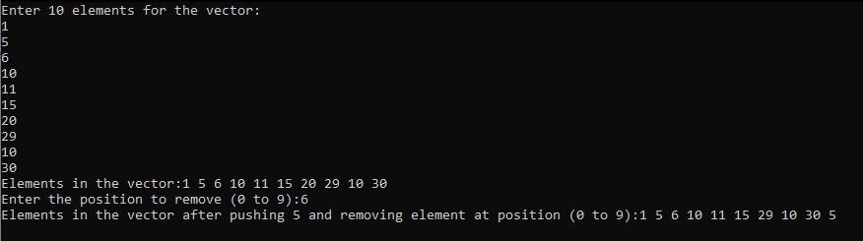}

# TASK 2

#include<iostream>

#include<vector>

using namespace std;

void sort(vector<int>& values) {

int n=values.size();

for(int i=0;i<n-1;i++) {

for(int j=0;j<n-i-1;j++) {

if(values[j]>values[j+1]) {

int temp=values[j];

values[j]=values[j+1];

values[j+1]=temp;

}

}

}

}

int median(vector<int>& values) {

sort(values);

int n=values.size();

int median;

if(n%2==0) {

median=(values[n/2-1]+values[n/2])/2;

}

else {

median=values[n/2];

}

return median;

}

int mode(const vector<int>& values) {

int maxfrequency=0;

int modeValue=0;

for(int i=0;i<values.size();i++) {

int frequency=0;

for(int j=0;j<values.size();j++) {

if(values[i]==values[j]) {

frequency++;

}

}

if(frequency>maxfrequency) {

maxfrequency=frequency;

modeValue=values[i];

}

}

return modeValue;

}

void equalgrades(const vector<string>& names,const vector<int>& grades,int mode) {

cout<<"Students with GradeEqual to Modevalue:";

for(int i=0;i<names.size();i++) {

if(grades[i]==mode) {

cout<<names[i]<<" ";

}

}

cout<<endl;

}

int main() {

vector<string> studentNames;

vector<int> studentGrades;

int num,mean,medianValue,modeValue;

cout<<"What is the number of students:";

cin>>num;

for(int i=0;i<num;i++) {

string name;

int grade;

cout<<"Name of student:";

cin>>name;

studentNames.push_back(name);

cout<<"Enter the grade percentage:";

cin>>grade;

studentGrades.push_back(grade);}

int sum=0;

for(int i=0;i<studentGrades.size();i++) {

sum+=studentGrades[i];}

mean=sum/studentGrades.size();

cout<<"Mean:"<<mean<<endl;

medianValue=median(studentGrades);

cout<<"Median:"<<medianValue<<endl;

modeValue=mode(studentGrades);

cout<<"Mode:"<<modeValue<<endl;

equalgrades(studentNames,studentGrades,modeValue);

return 0;

}